**SEMANTIC ANALYSIS**

**Semantic analysis helps artists to find out how and why people understand visual and verbal information the way they do. As a research technique, it can provide a means of predetermining whether or not an audience will understand your work as you intended it to be understood. It can also help artists to organize their research before starting a design.**

**Semantic analysis** is part of a larger research technique called semeiotics. The name of this research technique is based on the ancient Greek word sema, which means symbols or sign. According to this technique, there are three dimensions or levels of an object that can be distinguished.

1. **Syntactics**, which refer to the relationship between an object and the materials used to make or build it.
2. **Pragmatics,** which refer to the relationship between an object and the ways in which it is used
3. **Semantics,** which refer to the relationship between an object and the ways that it is perceived or understood.

As a general communications theory, semeiotics provides the basis for building an understandable form language that is appropriate for specific audiences. The semeiotic technique can be used as a brainstorming tool, as a means of surveying a large audience and as a means of analyzing already-existing material.

The major benefit of using this, or any research technique is the way that helps an artist to organize his/her ideas, impressions and research data prior to beginning the actual design process.

For the purpose of design, the most significant dimension is semantic. Semantic analysis allows the designer/artist to build a catalogue of possibilities from which to pick and choose the parts of a message or image. Strategically-made choices from the catalogue built with this technique allow the designer to control the ways that an audience can potentially respond to his or her work.

**There are three ways in which an object can be examined in the semantic dimension:**

1. **As an icon:** an object can be examined based on its physical appearance. In other words, an icon is exactly what you see in front of you. It is the big, overall picture.
2. **As an index or indication:** an object can be examined through its characteristics. In other words, an index could be the characteristics that let you know this particular object is in the room with you. They are the characteristics that make this object what it is, as opposed to another object.
3. **As a symbol:** an object can be examined based on single, immediate impressions or memories. In other words, a symbol is the first thing that pops into your head when someone mentions the name of an object. It is the one thing you remember after an object is no longer in front of you.

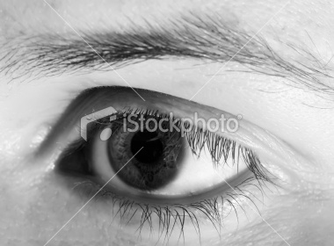

**Icon:** direct representation of an eye.

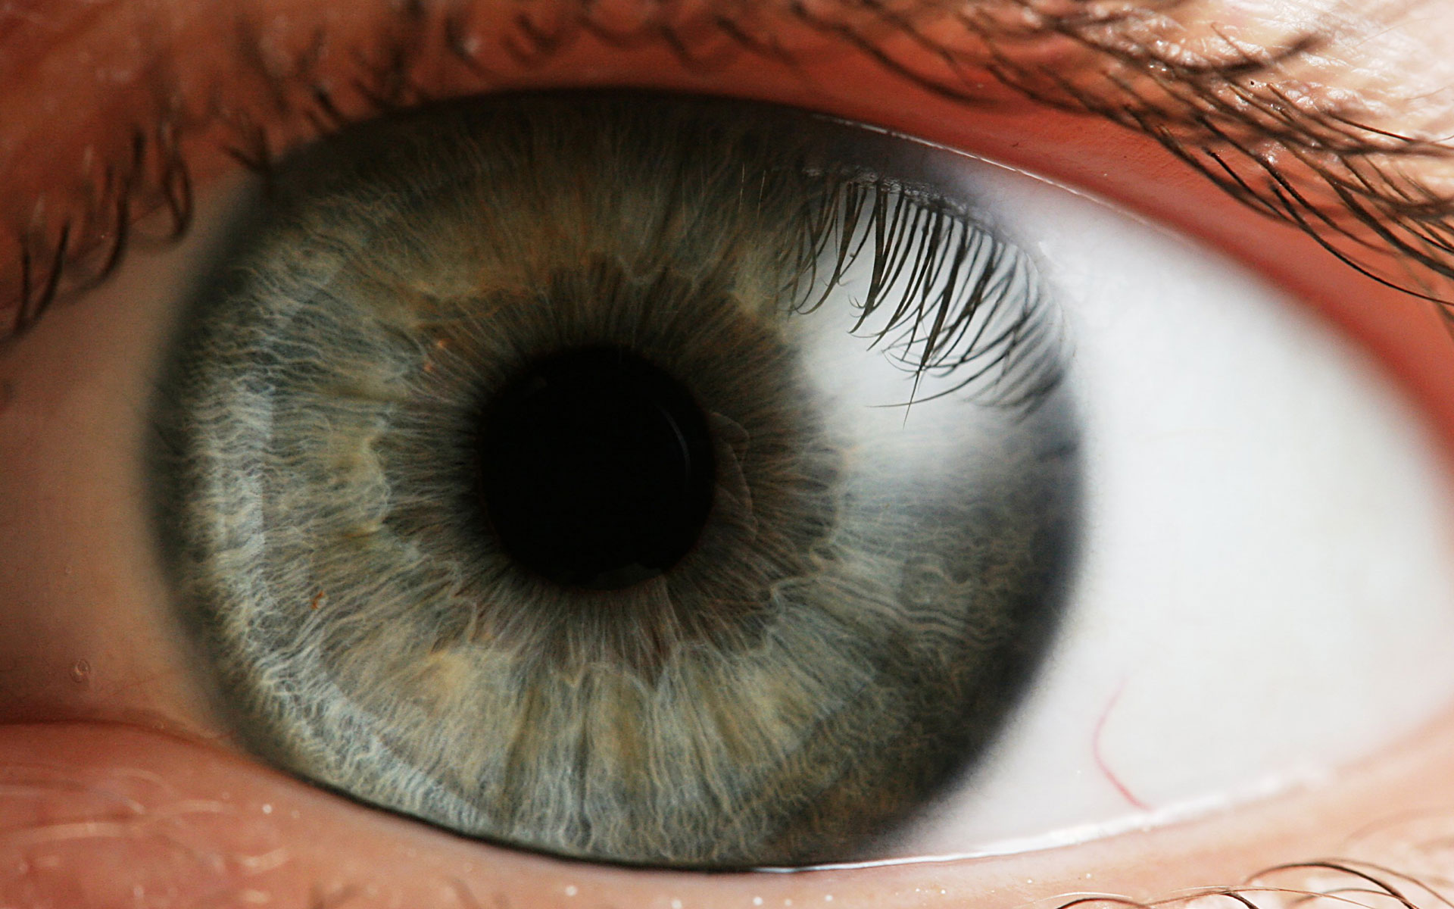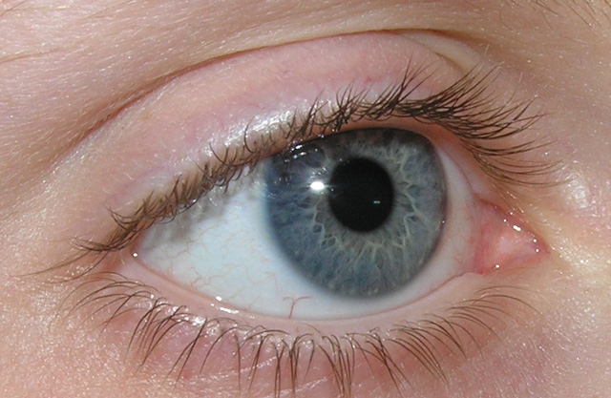

**Index or indication:** shape or silhouette, eyebrow, eyelashes, eyelid, pupil, color.

**eye**

**Symbol:** The color blue, shape or silhouette, the word eye, circle, oval.